Assignment # 5 – HTML and CSS Layout using Flex

Tasks to complete:
Refer the below screenshot to implement the layout using flex.
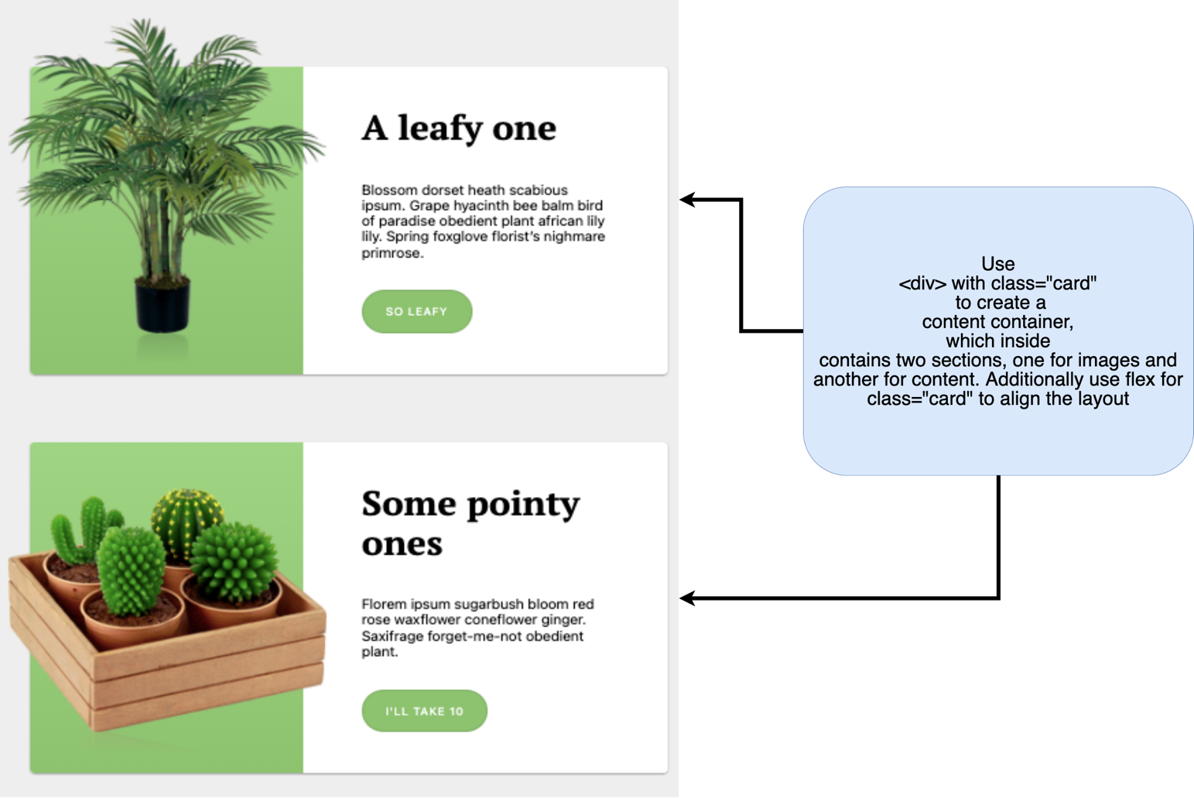

Image Reference:
- https://s3-us-west-2.amazonaws.com/s.cdpn.io/1145795/plant-1.png
- https://s3-us-west-2.amazonaws.com/s.cdpn.io/1145795/plant-4.png

Note: Follow the step in ReadMe file to run test cases.

Submission Steps
- Use Same previously cloned repo (No Need to create new repo, if Importing of repo already done.)

- Open you Repo in VSCODE and in terminal type cd "Repo name”.

- git checkout -b "BranchName"
Note: Branch Name should be the Assignment Number for example : Assignment 4, command would be
git checkout -b Assignment-4

- Start making changes in assignment4.html and assignment4.css.
- Proceed with Staging using command git add . or use Vs code extension
- Git commit or use Vs code extension
- Git Push or use Vs code extension
- Create the Merge Request as mentioned in below screenshots.
  - Select the branch that checkout in step 4
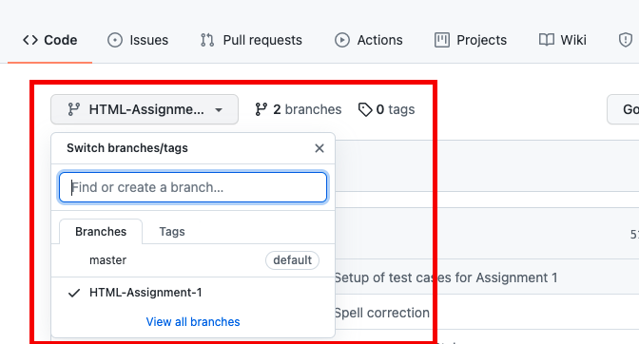

  - Click on “Pull request”
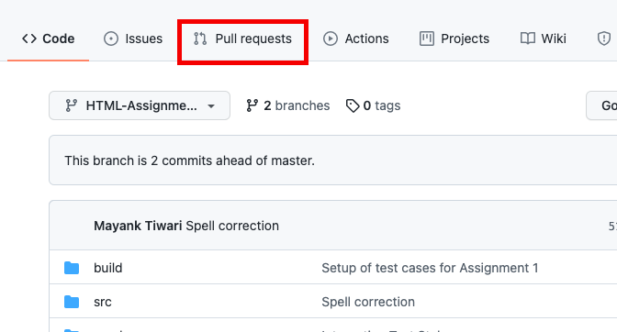
  - Click on “New Pull Request”
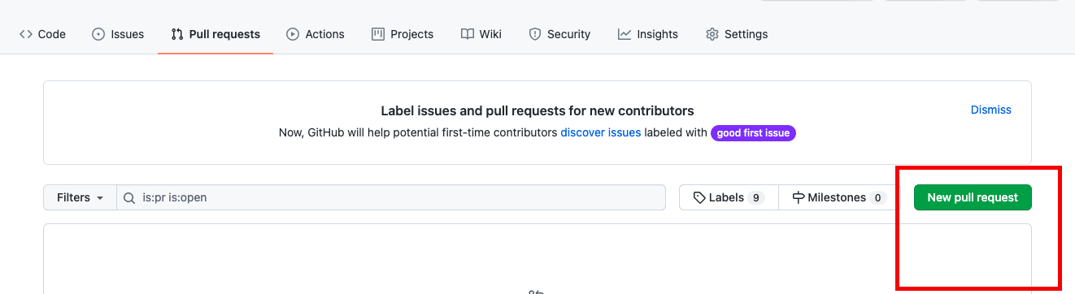

  - Select the branch that checkout in step 4
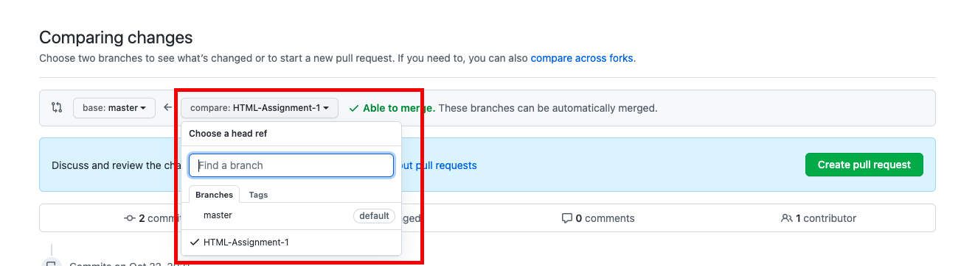
  - Create a pull request and share link of Request as your submission.
Please take screenshot of final output from your browser and keep in Pull Request description.
Share the Branch URL: https://github.com/{Username}/{Repo Name}/ pull/{Request Number}
